**Html Table**

**Theory Assignment 3**

**Q.1 Explain the structure of an HTML table and the purpose of each of the following elements: <table>, <tr>, <th>, <td>, and <thead>.**

**Ans:** An HTML table is used to organize data in rows and columns. Here's a breakdown of its structure and the role of each element:

· <Table>

o This is the main container that defines the entire table.

o All rows, header and data cells are placed inside this tag

· <tr> (Table Row)

o Represent a single row in the table

o Each row is made up of header cell and data cell.

· <th> (Table Header)

o Used inside a <tr> to define a header cell.

o Header cell are usually bold and centered by default.

o They describe the label or title for a column or row.

· <td> (Table Data)

o Represents a standard data cell in the table.

o It holds the actual content (like text, numbers, links, etc.) of the table.

· <thead> (Table Head)

o A sectioning element used to group all header rows.

o Typically contains one or more <tr> elements with <th> cells.

**Q.2 What is the difference between colspan and rowspan in tables? Provide examples.**

**Ans:** The main difference between of colspan and rowspan is colspan merge columns horizontally and rowspan merges rows vertically.

Example: **Colspan**

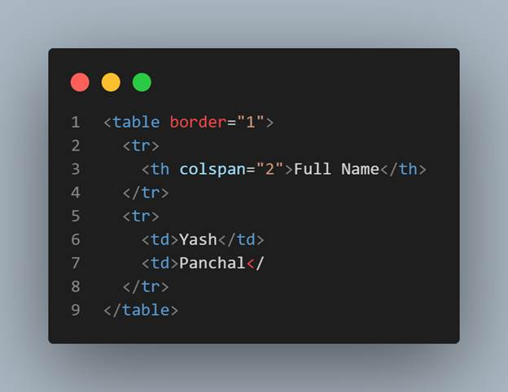

**Output:**

| Full Name | |
| --- | --- |
| Yash | Panchal |

**Rowspan**

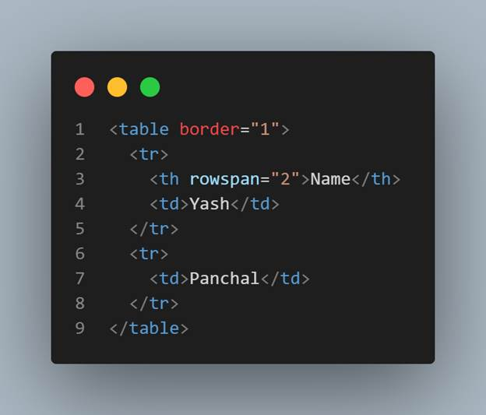

**Output:**

| Name | Yash |
| --- | --- |
| Panchal |

**Q.3 Why should tables be used sparingly for layout purposes? What is a better alternative?**

**Ans:** Problems with using tables for layout is:

1. Not made for layout:
   * Tables are meant to show data, not to design the structure of a webpage.
2. Hard to update:
   * If you want to change something in a table-based layout, it’s difficult and time-consuming.
3. Not good for mobile:
   * Tables don’t adjust well to small screens like phones or tablets. Your layout might break or look bad.
4. Messy code:
   * Tables require a lot of extra HTML tags, which makes your code long and harder to read.

What you should use instead:

A better way to create layouts is by using CSS with semantic tags like <div>,<header>,<section>,etc., and tools like Flexbox or Grid.

Use tables only for data, like a list of students or prices.  
For designing your page layout, always use CSS with semantic HTML. It’s cleaner, easier, and works better on all devices.